# Subject Shellharbour Surf Life Saving Club – Planning proposal to reclassify land from community to operational and permit a function centre – Lot 1 DP 211127, part of Lot 5, DP 218551 (10954526)

## To the General Manager

**Directorate: Community and Customers**

**Department: City Planning**

**Manager:** Geoff Hoynes – Group Manager City Planning

**Author:** Michael Tuffy – Senior Strategic Planner

## Summary

The purpose of this report is to seek Council’s resolution to prepare a planning proposal to amend Local Environmental Plan 2013 (LEP 2013) by reclassifying land from community to operational and allowing a function centre as an additional permitted use. The subject land contains the two existing Shellharbour Beach surf club buildings, their curtilage and the existing paved car parking area adjoining to the north of the buildings. See **Attachment 1**.

An associated planning proposal submission has been received by Council. The planning proposal submission has been lodged in response to Council’s Property Section’s proposal to enter into a long term lease. The lease would permit a function centre to operate, without the current limitation of being conducted for or on behalf of a surf club member: as stipulated in development consent No. 207/1989 as modified.

The land is zoned RE1 Public Recreation and classified as community land.

Function centres are currently a prohibited use in the RE1 zone and are an incompatible use with community land.

The planning proposal submission proposes to allow on the land, function centres as an additional permitted use, together with reclassifying the land from community to operational land.

## Background

What is a planning proposal?

A planning proposal is a document that explains the intended effect of a proposed amendment to a Local Environmental Plan (LEP), such as a rezoning or a land reclassification, to amend Shellharbour LEP 2013. A planning proposal sets out the justification for making the amendment which is known as the gateway process.

The gateway process has the following key steps:

1. *Planning proposal* - Council is responsible for the preparation of a planning proposal, which explains the effect of and justification for the plan.

2. *Gateway -* The Minister (or delegate) for the Department of Planning and Environment determines whether the planning proposal is to proceed. This gateway acts as a checkpoint to ensure that the proposal is justified before any further studies are done and resources are allocated to the preparation of a plan. A community consultation process is also determined at this time. Consultations occur with relevant public authorities and, if necessary, the proposal is varied.

3. *Community consultation* - the proposal is publicly exhibited (generally low impact proposals for 14 days, others for 28 days). A person making a submission may also request a public hearing be held.

4. A *public hearing* is required with *reclassifications*. This must be held no less than 3 weeks after exhibition.

5. *Assessment* - Council will consider public submissions and the proposal is varied as necessary prior to adoption. Parliamentary Counsel then prepares a draft local environmental plan — the legal instrument.

6. *Decision* - With the Minister’s (or delegate’s) approval the plan becomes law and is published on the [NSW legislation website](http://www.legislation.nsw.gov.au/).

The final decision on whether the plan becomes law and in what form it becomes law, rests with the Minister for Planning.

Should Council resolve to prepare a planning proposal, step one will progress.

The land

The subject land’s property description is Lot 1 DP 211127 and Part of Lot 5 DP 218551.

The land has a total area of 6440m².

On the land is the two surf club buildings currently leased by Shellharbour City Council to the surf club. This lease also includes the land the buildings occupy which is Lot 1 DP 211127 with an area of 4047m2.

The remainder of the subject land is occupied by the existing paved car parking area adjoining to the north of the buildings. This has an area of approximately 2400m2 and is described as Part of Lot 5 DP 218551.

Existing development consent for the surf club

The building located on the northern portion of Lot 1 was formerly used as the ‘Seaspray Function Centre’. However, the development consent specified that the use of the building for functions after 6pm was reliant on this use being conducted for, or on behalf of a surf club member (ref: Development Consent No. 207/1989 as modified). The surf club seeks formal approval to use the northern building on the subject site as a function centre, without this limitation.

Function centres currently prohibited

Function centres are currently prohibited under Shellharbour LEP 2013 in the RE1 Public Recreation zone. The proposed additional permitted use and reclassification would enable the land to be lawfully used for this purpose and will enable Council to enter into a long term lease of the buildings.

Function centres are defined under LEP 2013 as:

*function centre means a building or place used for the holding of events, functions, conferences and the like, and includes convention centres, exhibition centres and reception centres, but does not include an entertainment facility.*

Some types of functions can fall under LEP 2013’s definition of community facility and are therefore permissible in the RE1 Public Recreation zone. Noting the community facility definition in italic below, these are functions such as conferences, sports dinners and social club meetings for the physical, social, cultural or intellectual development of the community.

*community facility means a building or place:*

*(a)  owned or controlled by a public authority or non-profit community organisation, and*

*(b)  used for the physical, social, cultural or intellectual development or welfare of the community,*

*but does not include an educational establishment, hospital, retail premises, place of public worship or residential accommodation.*

However, it is unlikely that functions in the nature of either weddings or other private parties would constitute a use of the building for the physical, social, cultural or intellectual development or welfare of the community. These types of functions would fall under the LEP 2013 definition of function centre.

Effect of the planning proposal submission

The planning proposal submission seeks to permit a full array of function types, not just those types that can fall under the definition of community facility. It does this by specifying function centres as an additional permitted use on the subject RE1 Public Recreation zoned land, but not on any other RE1 land.

The existing classification of the land under the Local Government Act (the LG Act) is community land. Section 46 of the LG Act provides legal parameters for leases over community land. These include a need to relate to the provision of goods, services and facilities, and the carrying out of activities, appropriate to the current and future needs within the local community and of the wider public in relation to public recreation or the physical, cultural, social and intellectual welfare or development of persons.

It is the position of the proponents and Council officers that the proposed land uses as allowed within the definition of a function centre will not all fit within the requirements of community land under Section 46. Therefore the land needs to also be reclassified as operational land to permit a full array of function centre types, not just those types that can fall under the definition of community facility under LEP 2013.

How the subject land was determined

When first lodged with Council, the planning proposal submission only included the northern surf club building which has the proposed function centre area. In response, Council officers indicated that a function centre would need to provide adequate parking. Because function centre parking would be ancillary to a function centre, it would also be defined as function centre. Hence the proponent revised the planning proposal submission to include the existing paved parking area adjoining the surf club buildings to the north.

The revised planning proposal submission also includes the entire Lot 1 DP 211127 to provide potential flexibility for function centre use in the future.

External consultation

If the Council resolves to endorse the preparation of this planning proposal it will be referred to the Department of Planning & Environment for review and gateway determination. If endorsed, the planning proposal will be put on public exhibition. To coincide with the public exhibition, Council will write to the adjoining land owners and also place an advertisement in the Lake Times.

The gateway process will identify any further consultation that will need to be undertaken.

Parking

The revised planning proposal submission addresses issues initially raised by Council officers about the scenario where any future function centre operator seeks to conduct functions at for instance heavy beach usage times, when parking will be in high demand.

The submission indicates that as part of any future development application, it would need to be demonstrated that sufficient parking arrangements are made for:

• a function centre,

• beach users, and

• club members carrying out activities associated with the club.

The revised planning proposal goes on to provide an analysis of potential car parking arrangements. It uses a floor space figure of 277m2 being for the customer area comprising the existing main hall area and associated separate bar within the existing northern building.

Chapter 13 of the Shellharbour Development Control Plan provides the required car parking spaces specifically relating to a ‘***Reception Function Centre’*** as follows:

*Whichever is the greater of:*

*1 space / 4m2 customer area (both indoor & outdoor) + 1 space/ staff present on the site at any one time,*

*or*

*1 space / 3 seats+ 1 space / staff present on the site at any one time*

For the purpose of the planning proposal the proponents have used the *1 space / 4m2 customer area (both indoor & outdoor) + 1 space/ staff present on the site at any one time,* to calculate parking. This equates to 69 car parking spaces required for the floor area component and allows for additional staff spaces. The planning proposal indicates there are 75 car parking spaces provided on the subject parking area.

Any future function centre development application will be subject to parking assessment and is likely to require at least in the order of 75 spaces. To cater for any function held during heavy beach usage, the development application (DA) would need to demonstrate where overflow parking is accommodated. The proponent has elected to demonstrate this at planning proposal stage to minimise potential DA issues and has submitted a plan indicating overflow parking for beach users could be provided on the foreshore area north of the existing car park. This would be subject to further assessment at any function centre development application stage.

**Financial / Resources Implications**

Planning proposal fees have been paid in accordance with Council’s fees and charges.

Legal advice on plans of management was obtained regarding the application of plans of management to land that has been reclassified to operational. See Plans of management heading below.

Preparation of the planning proposal will also utilise staff time and resources.

**Legal and Policy implications**

While reclassifying land from community to operational allows it to be sold by Council, the intent of the planning proposal is to facilitate use of the land for a function centre and not to sell any of the land. Future sale of the land however cannot be ruled out once and if it becomes operational. Community land cannot be sold.

The relevant *Environmental Planning & Assessment Act* issues are outlined in the following sections of this report.

Draft State Environmental Planning Policies, State Environmental Planning Policies (SEPPs), Deemed State Environmental Planning Policies

Council officers have made an assessment of the planning proposal against the SEPPs.

Under the Gateway system these assessments can occur at different stages in the process.

Based on Council’s assessment, the planning proposal is consistent with or not applicable to the SEPPs.

The Department of Planning and Environment (DPE) will review Council's assessment as part of its gateway determination.

Local Planning Directions (*S117(2) Environmental Planning & Assessment Act*)

Council officers have made an assessment of the planning proposal against the directions in consultation with the DPE. Under the Gateway system these assessments can occur at different stages in the process. Based on Council's assessment there is an inconsistency with the following directions:

4.1 Acid Sulfate Soils

The planning proposal is inconsistent with this direction because it involves an intensification of land uses on the site, by introducing a function centre as an additional permitted use. The inconsistency is considered to be of minor significance as any future function centre is likely to operate from the existing building. Hence groundworks are unlikely. Should groundworks be proposed as part of any future development application, acid sulfate soils need to be addressed under Clause 6.1 of Local Environmental Plan 2013.

4.3 Flood Prone Land

The planning proposal is inconsistent as it would permit a significant increase in the development of land partially affected by a flood planning area, by allowing function centres as an additional permitted use.

The inconsistency is considered to be of minor significance as any future development application will address flooding. Any future function centre is likely to operate from the existing building.

It will be the Department of Planning and Environment that decides as part of its gateway determination, firstly whether the planning proposal is inconsistent with any direction and if so whether an inconsistency can be justified or is of minor significance.

Practice Note PN 16-001 Classification and reclassification of public land through a local environmental plan

This DPE practice note (PN) provides guidance on reclassifying public land through a local environmental plan. It includes a checklist of what the PN requires to be addressed which includes but is not limited to:

* whether the land is a public reserve
* the strategic and site specific merits of the reclassification
* whether the planning proposal is the result of a strategic study or report
* whether the planning proposal is consistent with council’s community plan or other local strategic plan
* a summary of council’s interests in the land
* current uses and leases
* current or proposed business dealings such as any agreement for sale or lease of the land
* how council may or will benefit financially, and how these funds will be used

The PN requirements have been addressed and a table to this effect comprises **Attachment 3** which will be included in any gateway submission to the DPE.

Of note is that the planning proposal is not the result of any strategic study or report. Verbal advice from the DPE is that a gateway submission can be considered without strategic justification.

Plans of management

There are two existing plans of management applying to the subject land. Plans of management (POM) are required under the Local Government Act, for community land. Under section 42(2)(a) of the Local Government Act, a plan of management ceases to apply to land if the land is reclassified as operational land.

One is the Shellharbour Surf Club/Sea Spray Function Centre POM which applies to that part of the subject land containing the two existing surf club buildings and their curtilage. This POM would cease to apply to any land upon any reclassification of the land.

The other is the Beverley Whitfield Park/Shellharbour Swamp POM which applies to the that part of the subject land comprising the existing paved car parking area adjoining to the north of the buildings, together with a broader area outside of the subject land. Upon any reclassification of the land, this POM would cease to apply to the subject land and continue to apply to the broader area outside of the subject land.

Precedent

Although this planning proposal may be seen as a precedent for future similar proposals for function centres on RE1 Public Recreation zoned land, classified community, by establishing a general in principle acceptability: any such proposal would be subject to the associated assessment framework and could not rely on precedent.

**Public / Social Impact**

The planning proposal is intended to have a positive economic effect for the surf club by allowing it to lease area for functions. This in turn enables a positive social benefit by assisting in the surf club’s financial viability. The surf club conducts activities such as patrol/rescue, water safety education and carnivals.

The planning proposal is intended to have a positive economic effect for the operator of the functions. Functions are intended to have a positive economic and social effect by providing employment.

The ability to conduct a function centre is intended to provide social benefits. Any potential negative social effect/amenity impact, from functions will be assessed as part of the planning proposal and if progressed, the subsequent development application.

**Link to Community Strategic Plan**

The planning proposal to reclassify land from community to operational and permit a function centre, supports the following objectives and strategies of the Community Strategic Plan:

Objective: 1.1 Vibrant, safe and inclusive city

Strategy: 1.1.1 Encourage and support activities and events where communities can gather and celebrate.

Objective: 2.3 A liveable City that is connected through places and spaces.

Strategy: 2.3.2 Undertake all land use planning addressing social, economic and environmental principles whilst reflecting the current and future community's needs.

Strategy: 2.3.4 Facilitate the provision of development that meets the changing needs and expectations of the community.

Strategy: 2.3.6 – Deliver sustainable management of the community’s assets for current and future generations.

Objective 3.2 – Supported by a strong local economy with business and employment opportunities.

Strategy 3.2.2 – Encourage opportunities for local businesses to grow and prosper.

Strategy 3.2.3 – Present a positive image of our City to create and promote work, investment and lifestyle opportunities.

Strategy 3.2.4 – Support educational and employment opportunities that retain young people, attract new workers and provide opportunities for the unemployed.

## Consultations

**Internal**

Group Manager Services

Group Manager Asset Strategy

Group Manager Design

Group Manager City Development

Manager Property

Aboriginal Community Liaison Officer

Acting Team Leader City Development

**External**

Marsdens Law Group

A public hearing is required to be held as part of any reclassification process and this would take place no less than 3 weeks after any public exhibition.

Following the exhibition period and public hearing, submissions will be reviewed and reported back to Council.

**Political Donations Disclosure**

Under Section 147(4) of the *Environmental Planning and Assessment Act 1979* (the Act) a person who makes a relevant planning application to Council is required to disclose any reportable political donations and gifts made by any person with a financial interest in the application within the period commencing two years before the application is made and ending when the application is determined, including:

a) all reportable political donations made to any Councillor of this Council;

b) all gifts made to any Councillor or employee of this Council.

Under Section 147(5) of the Act, these disclosure requirements also apply to a person, or any associate of a person, who makes a relevant public submission to Council in relation to a relevant planning application.

**Note**: Section 147(1) of the Act states: 'political donations or gifts are not relevant to the determination of any such planning application, and the making of political donations or gifts does not provide grounds for challenging the determination on any such planning application'.

## Recommendation

**That:**

1. **Council prepare a Planning Proposal (No 0005/2016) to amend Shellharbour Local Environmental Plan 2013 to allow a function centre as an additional permitted use and reclassify the land from community to operational and incorporate the proposed zoning and planning controls in Attachments 2.**
2. **Council authorise the General Manager to submit Shellharbour Local Environmental Planning Proposal No 0005/2016 to NSW Planning & Environment in accordance with section 56 of the *Environmental Planning & Assessment Act 1979* for review and gateway determination.**
3. **Council delegate to the General Manager authority to make minor mapping and Local Environmental Plan instrument changes to Shellharbour Local Environmental Plan 2013 Planning Proposal No 0005/2016 if and as required by the Department of Planning & Environment's LEP Review Panel and gateway determination.**
4. **Council and Council staff not use the plan-making delegations from the Minister for Planning on this Planning Proposal.**
5. **Shellharbour Local Environmental Plan 2013 Planning Proposal No 0005/2016 be publicly exhibited in accordance with the gateway determination.**
6. **A public hearing be held into the proposed reclassification no less than 3 weeks after any public exhibition.**
7. **After the public exhibition period has closed and public hearing held, a report be submitted to Council for consideration detailing the outcomes and with further recommendations regarding adoption.**

## End Section

|  |  |
| --- | --- |
| Approved for Council's consideration: | G:\Community and Customers\Signatures\Sign - G- Hoynes.png |

**Date of Meeting:** 31 October 2017

**Attachments**

1. Subject land plan
2. Table of properties showing existing and proposed planning controls
3. Table addressing Practice Note 16 – 001 and supporting documents **(under separate cover)**

**Attachment 1 – Subject Land Plan**

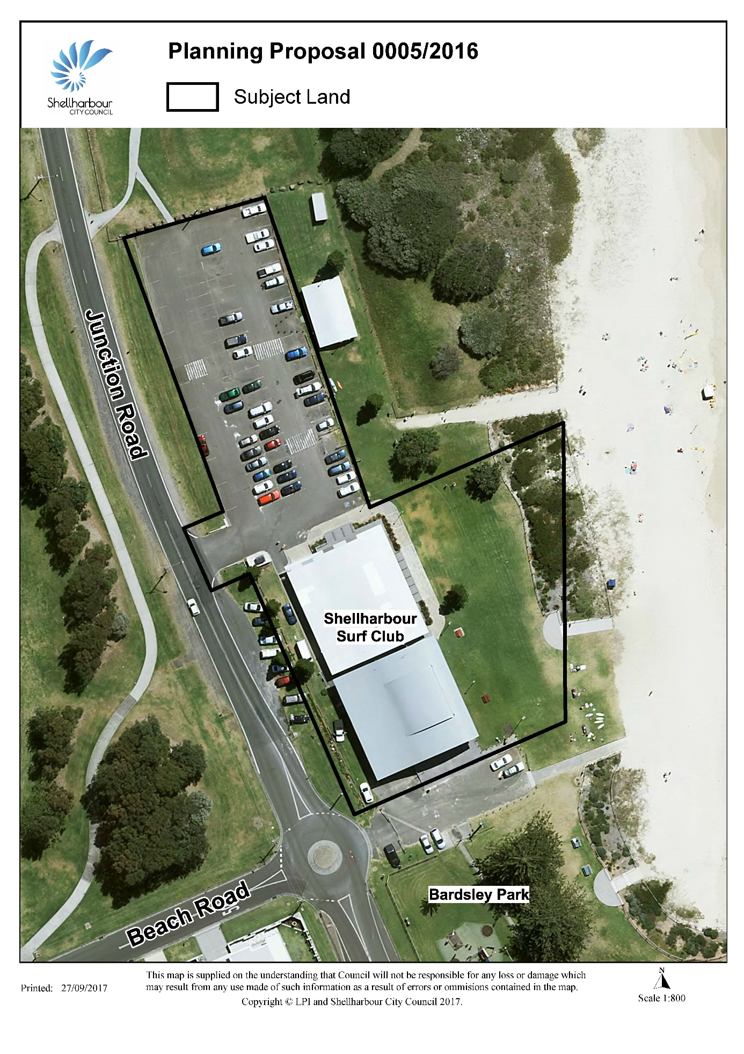

**Attachment 2 - Table of properties showing existing and proposed planning controls**

